

**ECE 5734**

Embedded Systems Verification & Validation

**Project Progress Report on**

VERIFICATION OF SAFETY AND SECURITY REQUIREMENTS IN AUTONOMOUS VEHICLE

**By**

Cory Ness

Kokila Subramanian

**Under the Guidance of**

Professor Ramesh Sethu

Winter 2022

# **Abstract**

# **Introduction**

Concept of connected devices and cooperative and intelligent self-driving transportation systems are thriving the economy over the past decade. Society of Automobile engineering (SAE) have defined 5 levels of automation depending on its functionalities and capabilities. Today’s commercially available autonomous vehicle systems have reached the 4th level of autonomy. The major constraint of autonomous vehicle in urban traffic should be capable of navigating through the varying city’s traffic conditions, perform complex maneuvers like parking, moving at intersections, merging in lane, and must operate with the diverse geographical boundary conditions. Verification and validation of the requirements of the system can add trustworthiness to the autonomous system under development.

# **Objective of Project**

This project aims to develop a model and verify the functional requirements of an autonomous vehicle system using the LabVIEW simulation tool. The autonomous vehicle model developed was based primarily on physics and research done by others, which we implement in LabVIEW. To identify the safety requirements of autonomous driving system that includes obstacle detection, maintain stability, automatic transmission control and accidental failure prevention. Using the model, we will attempt to drive the vehicle based on the safety requirements of the currently running test and verify that the model’s outputs are within acceptable safety criteria for the test that’s running.

# **Safety Requirements**

Understanding the autonomous vehicle model, the dynamic behavior and evaluating the functionalities involves two wide process, verification and validation, implemented from the early stage of the product development. The safety requirements definition for autonomous vehicles are listed under the following factors:

* Determine Location of the vehicle with the use of perceptional sensors and environmental conditions.
* Perceive relevant static and Dynamic Objects in Proximity using the traffic condition and sensor data
* Predict Future Behavior of Surrounding Objects from the perceived data.
* Create Collision Free and Lawful Driving Plan by interpreting the information collected from environment and ADS manger.
* Execute and Actuate right Driving Plan by controlling the actuators.
* Communication with other Road users
* Ensure Controllability of Vehicle with seamless braking, lane control and object detections capabilities.

# **Kinematics and Dynamic Autonomous Vehicle Model using LabVIEW**

## **Model Based Car Simulation**

The kinematics and dynamic Car simulator model is developed using LabVIEW simulation tool. It provides the physical variables of the autonomous vehicle based on the inputs over simulation time. The model equations are provided by the authors of “Kinematic and Dynamic Vehicle Models for Autonomous Driving Control Design”, however the implementation of those models in LabVIEW were performed by us, with the implementation available in the screen capture shown below.

Figure 1. Car Simulator Block Diagram

## **Test Generator**

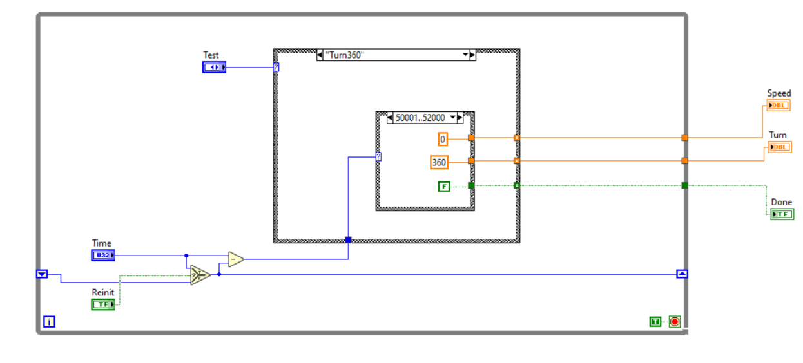The Test Generator is used to select the targets for the model to verify the Test cases for the safety requirements defined. It specifies the Test cases to run among the various test cases listed.

Figure 2. Test Generator Block Diagram

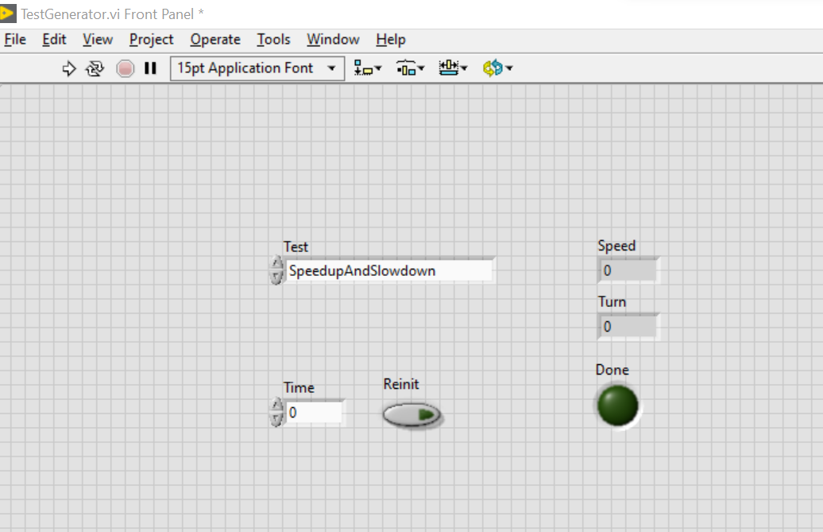

Figure 3. Test Generator Front Panel

# **Test Cases Summaries**

## Avoid Obstacle

The Avoid Obstacle case is used to verify that the vehicle can appropriately react to an obstacle in front of itself, and maneuver around it, avoiding the collision while still maintaining comfort for the passengers. The Avoid Obstacle test involves the following series of actions:

1. Accelerate to highway speeds
2. Perform a left-hand turn to avoid the obstacle
3. Perform a right-hand turn to not drive off the road
4. Drive straight as the obstacle passes
5. Perform a right-hand turn to drive back to the desired lane
6. Perform a left-hand turn to be aligned to the lane and drive along it

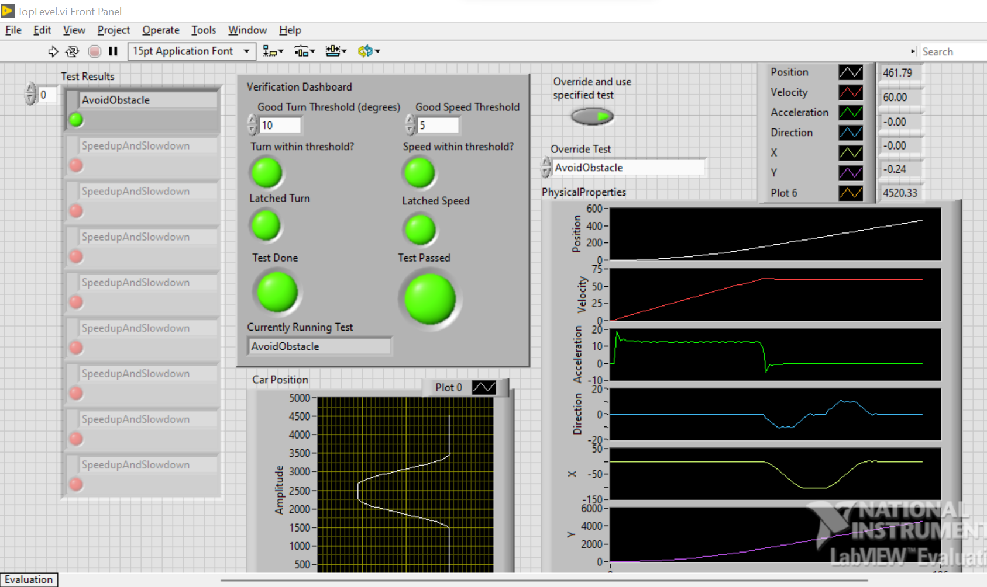

Figure 4:Screenshot of the Avoid Obstacle test case

## Back-in parking

## Drive Straight

## Figure 8

The Figure 8 case is used to verify that the vehicle can accurately perform a complex maneuver that involves both left and right turns. While there isn’t necessarily an analog of this in real life, it stress-tests the system and model by performing a maneuver and helps ensure the system is functional. The Figure 8 test involves the following series of actions:

1. Accelerate to 10mph
2. Perform a right-hand turn to a full 360 degrees
3. Perform a left-hand turn to a full 360 degrees
4. Decelerate back to 0mph

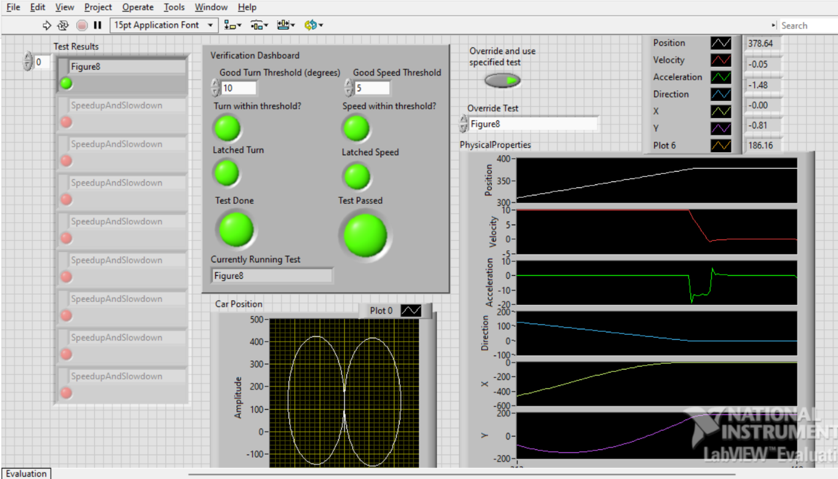

Figure 5: Screenshot of the Figure 8 test case

## Lane Change

## Speed up and Slow Down

## Turn 360

# **Successes in the project**

* Complete basic model of autonomous vehicle
* Varied test cases that cover vast majority of use cases for the vehicle
* Every case implemented has a passing test
* Succinct method of verifying the overall system by performing all tests in sequence

# **Points of further development**

* Even more test cases
* More complex model
* More monitors

### **References**

1. Ailon, A., Berman, N., & Arogeti, S. (2005). On controllability and trajectory tracking of a kinematic vehicle model. *Automatica*, *41*(5), 889–896. https://doi.org/10.1016/j.automatica.2004.11.025
2. *Benz: Safety First for automated driving.* Mercedes. (2019, July 4). https://www.mercedes-benz.com/en/innovation/safety-first-for-automated-driving/?csref=sm_fbk_gims2019_pc.html
3. Kang, C. M., Lee, S.-H., & Chung, C. C. (2018). Multirate Lane-keeping system with kinematic vehicle model. *IEEE Transactions on Vehicular Technology*, *67*(10), 9211–9222. https://doi.org/10.1109/tvt.2018.2864329
4. Kong, G., Pfeiffer, Mark., Schildbach, G., and Borrelli, F. *Kinematic and dynamic vehicle models for Autonomous Driving Control Design*. IEEE Xplore. (n.d.). https://ieeexplore.ieee.org/document/7225830
5. Sabaliauskaite, G., Liew, L., & Cui, J. (1970, January 1). *[PDF] Integrating Autonomous Vehicle Safety and security analysis using STPA method and the six-step model: Semantic scholar*. undefined. https://www.semanticscholar.org/paper/Integrating-Autonomous-Vehicle-Safety-and-Security-Sabaliauskaite-Liew/dcc9ab963f2f4d97b5dc81d0e8df0708008d36a8